Brick/Paver Program Order Form
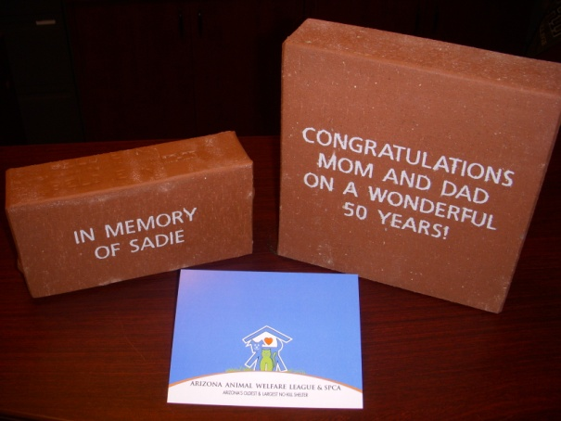
Each brick ordered will support the animals and programs of AAWL & SPCA. Bricks will be etched with your personal engraving and be placed outside of the AAWL & SPCA Adoption Center.

Replica bricks are available for purchase in addition to your purchased brick. Replica bricks are a reproduction of your purchased brick and are available for pick up at the Adoption Center for you to display in your home or office. Shipping of replica bricks is available for an additional fee.

Brick Inscription:

- “Characters” include spaces, punctuation, or any standard computer keyboard symbol, etc.
- All inscriptions will be capitalized, centered, and printed exactly as designated

Please provide your inscription below for your brick or paver within the squares. For additional orders, please use another order form. For help with your order please call the development office, (602) 273-6852 ext. 106, or email development@aawl.org. Thank you again for supporting the Arizona Animal Welfare League & SPCA!

Order Information:

Name: ____________________________________

Address: __________________________________

City: _______________ State: _____ Zip: ________

Phone: ___________________________________

Email: ____________________________________

$250.00 – 4”x8” Brick
(up to 3 lines of 15 characters)

Yes, I would like a replica brick - additional $100.00.

$500.00 – 8”x8” Paver
(up to 6 lines of 15 characters)

Yes, I would like a replica paver - additional $175.00.

Payment Information:

Pre-Paid Cash Check Charge

CC#: ______________________________________

Expiration: _______________ Security Code:_____

